📖 Explanatory Notes

1. Introduction to Islam
Islam is derived from the Arabic word Salama, which means peace and submission. In religion, it means submitting to the will of Allah, believing in His Oneness, and rejecting polytheism. It is not limited to worship but is a complete code of life that provides guidance in every aspect—spiritual, social, moral, and economic. A Muslim proves submission through worship, obedience, and avoiding shirk ,following his commands and avoiding polytheism.

2. Islam as a Deen
Islam is not just a religion but a Deen—a complete system of life. Allah declares in the Qur’an (3:19, 3:85) that Islam is the only accepted way in His sight, and no other path will be accepted in the Hereafter.
This shows Islam is comprehensive, covering belief, worship, society, economy, and ethics.
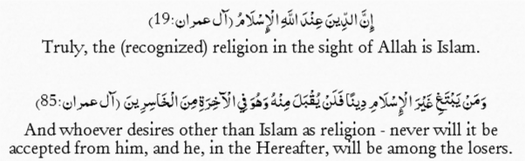

3. Structure of Islam
Islam is built on three main dimensions:
- Beliefs (Aqeedah / Iman): Core faith in Allah, angels, divine books, prophets, the Hereafter, and destiny
- Practices (Ibadah / Pillars): The five pillars—Shahadah (faith declaration), Salah (prayer), Sawm (fasting), Zakat (charity), and Hajj (pilgrimage).
- Affairs & Ethics: Social dealings, trade, economy, and moral values such as honesty, patience, forgiveness, and justice

4. Belief (Iman) and Its Importance
The word Iman means belief and trust. In Islamic terms, it means affirming everything Prophet Muhammad ﷺ conveyed from Allah. Iman has three essential parts:
- Belief in the heart (firm conviction).
- Profession by the tongue (saying Shahadah).
- Actions by the body (living according to Islam).
Without Iman, actions are not accepted by Allah. Prophet ﷺ said: “You will not enter Paradise until you believe.” (Muslim). This shows faith is the foundation of good deeds.
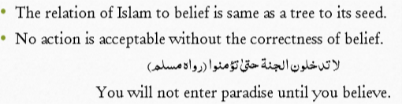

5. Basic Beliefs (Articles of Faith)
Islam teaches six articles of faith:
- Belief in Allah: The one true Creator, without partners.
- Belief in Angels: Spiritual beings who obey Allah and perform His commands.
- Belief in Divine Books: Torah, Zabur, Injil, and Qur’an (final book).
- Belief in Messengers: Prophets sent to guide humanity, ending with Prophet Muhammad ﷺ.
- Belief in the Hereafter: Resurrection, accountability, Paradise, and Hell.
- Belief in Destiny (Qadr): Everything, good or bad, happens by Allah’s will.
The Hadith of Jibreel explains both Islam (five pillars) and Iman (six beliefs), summarizing the foundation of faith and practice. 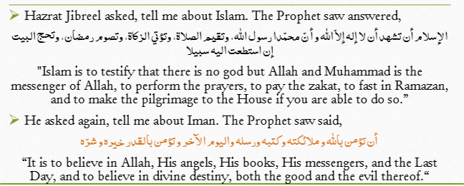
📖 Six Articles of Faith (Expanded Notes)

1. Belief in Allah (ﷻ)
- Allah is the one and only Creator of the universe.
- He has no partners, no children, and no equals.
- All power, knowledge, and authority belong to Him alone.
- Believing in Allah includes His existence, Oneness (Tawheed), and attributes (e.g., All-Knowing, Merciful, Powerful).
- Worship is directed to Allah only.

2. Belief in Angels (Malaikah)
- Angels are created from light and are unseen beings.
- They never disobey Allah and carry out His commands.
- Major angels include:
  - Jibreel (Gabriel): brings revelation.
  - Mikaeel (Michael): controls rainfall and sustenance.
  - Israfeel: will blow the trumpet on the Day of Judgment.
  - Malik: keeper of Hell.
  - Munkar & Nakeer: question in the grave.
- Belief in angels strengthens awareness of accountability.

3. Belief in Divine Books
- Allah revealed books to guide humanity.
- Main revealed scriptures:
  - Torah (Taurat): to Prophet Musa (Moses).
  - Zabur (Psalms): to Prophet Dawud (David).
  - Injil (Gospel): to Prophet Isa (Jesus).
  - Qur’an: to Prophet Muhammad ﷺ (final and unchanged).
- Qur’an is the last and preserved book, valid for all times and people.

4. Belief in Messengers (Rusul)
- Allah sent prophets to guide mankind with His message.
- Every nation was sent a prophet.
- Major prophets: Adam, Nuh (Noah), Ibrahim (Abraham), Musa (Moses), Isa (Jesus), and Muhammad ﷺ.
- Prophet Muhammad ﷺ is the final messenger; no prophet will come after him.
- Following prophets means obeying their teachings from Allah.

5. Belief in the Hereafter (Akhirah)
- Life does not end with death; everyone will be resurrected.
- People will be judged based on their deeds.
- Rewards: Paradise (Jannah) for the righteous.
- Punishment: Hell (Jahannam) for the disbelievers and sinners.
- Stages include: grave questioning, resurrection, judgment, Sirat bridge, and eternal life.
- This belief motivates Muslims to live responsibly.

6. Belief in Destiny (Qadr)
- Everything happens by Allah’s knowledge and will.
- Both good and bad events are part of Allah’s plan.
- Humans have free will to choose, but Allah already knows what choices they will make.
- Belief in Qadr brings patience in hardships and gratitude in blessings.
- It teaches reliance on Allah and acceptance of His decree.
✅ These six beliefs form the foundation of Iman. Without them, a Muslim’s faith is incomplete.

📖 Belief in Allah (SWT) – Notes & Explanation

1. God’s Existence
Brief Notes:
- Some deny God using intellect or science.
- Science changes, Islam is unchanging.
- Unseen things exist (waves, Wi-Fi, emotions).
- Universe and humans are proofs of Allah’s existence.
Explanatory Notes:
Many people reject God’s existence based on science or reasoning. But science is temporary and changes over time, while divine truth is permanent. There are countless unseen realities (sound, radio, emotions) that science accepts, proving unseen existence is real. The universe’s perfect system and human creation testify to a Creator.
The Qur’an (At-Tin:4) confirms: “We created man in the best composition.” Both Qur’an and Hadith provide strong proofs of Allah’s existence.

2. How Can We Know Allah (SWT)?
Brief Notes:
- Through His names & attributes.
- Through signs in nature.
- Through prophets’ teachings.
- Through history of nations.
Explanatory Notes:
Allah can be known in different ways:
- By His beautiful names and attributes (All-Knowing, All-Seeing).
- Through His signs in creation like the heavens, stars, and earth.
- Prophets were sent to link humanity with the Creator, teaching Tawheed.
- History shows Allah guiding the righteous and punishing wrongdoers. These sources make Allah’s reality clear.

3. Belief in Allah (Tawheed)
Brief Notes:
- Tawheed = Oneness of Allah.
- Core foundation of Islam.
- Without Tawheed, no Islam.
- All prophets preached Tawheed.
Explanatory Notes:
Tawheed literally means making one. In Islam, it is believing in Allah’s absolute Oneness. Surah Al-Ikhlas explains Tawheed clearly: Allah is One, Eternal, and Independent. Tawheed is the cornerstone of Islam; without it, one cannot be Muslim. Every prophet brought the message of Tawheed (Qur’an 21:25). It distinguishes Islam from all false beliefs.

4. Types of Tawheed
Brief Notes:
- Essence – Allah’s being is One.
- Attributes – His qualities are unique.
- Actions – Allah alone controls creation.
- Worship – Only He deserves worship.
- Supplication – Only He should be asked.
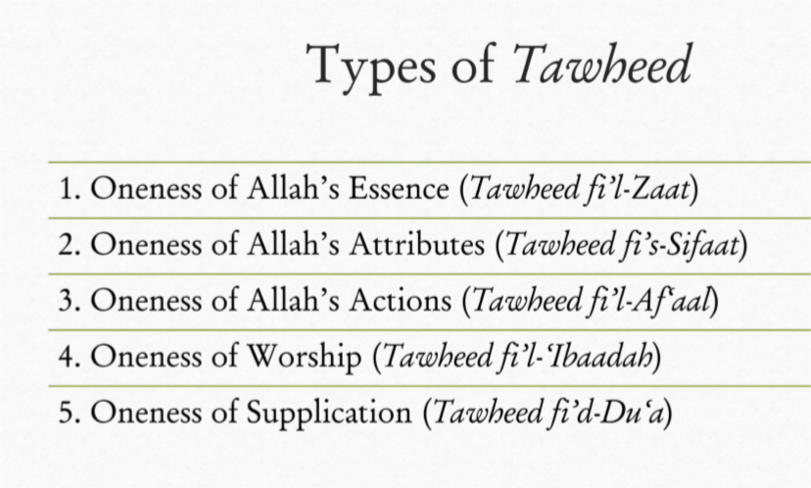
Explanatory Notes:
- Oneness of Essence (Zaat): Allah has no partner or equal in His existence.
- Oneness of Attributes (Sifaat): No one shares Allah’s qualities (knowledge, power, mercy).
- Oneness of Actions (Af‘aal): Only Allah creates, gives life, and sustains.
- Oneness of Worship (‘Ibaadah): Worship (prayer, fasting, sacrifice) is only for Allah.
- Oneness of Supplication (Du‘a): Requests, prayers, and reliance must be directed to Allah alone.

5. Polytheism (Shirk)
Brief Notes:
- Shirk = associating partners with Allah.
- Worst sin, never forgiven if not repented.
- Leads to eternal Hell.
- Types: Major and Minor.
Explanatory Notes:
Shirk is the opposite of Tawheed, meaning associating partners with Allah. It is the gravest sin and is unforgivable if a person dies without repentance (Qur’an 4:48). Qur’an calls it a “great injustice” (Luqman 13). Punishment is eternal Hell (Qur’an 5:72).
- Major Shirk: Believing in partners in Allah’s being, attributes, actions, worship, or supplication.
- Minor Shirk: Acts like showing off in worship (Riya). Prophet ﷺ warned that hidden shirk (e.g., praying to impress others) is more dangerous than Dajjal.
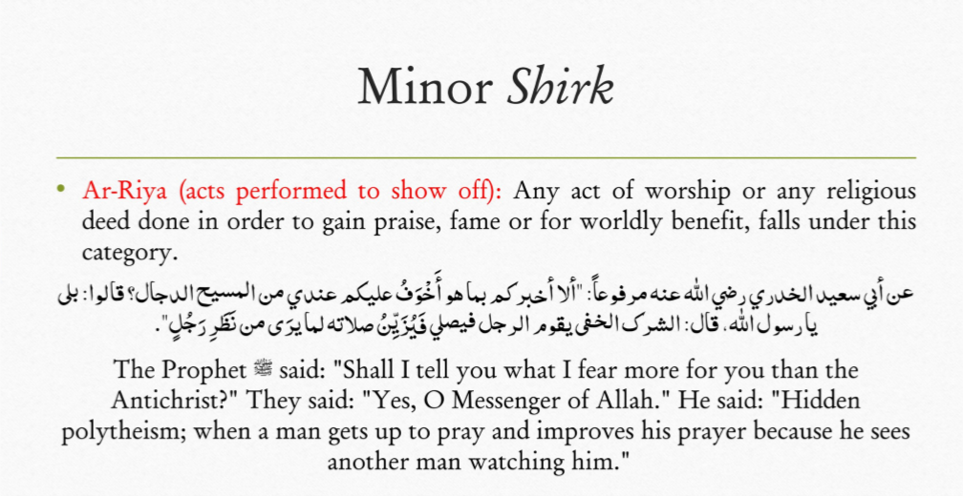

6. Benefits of Tawheed
Brief Notes:
- Deeds accepted only with Tawheed.
- Leads to forgiveness.
- Saves from Hell, grants Paradise.
- Prophet’s ﷺ intercession.
- Gives self-respect, humility, bravery, obedience.
Explanatory Notes:
Tawheed brings many blessings:
- Acceptance of deeds: Without Tawheed, worship is rejected.
- Forgiveness of sins: Sincere belief erases sins.
- Freedom from Hell & Paradise: Whoever dies on Tawheed enters Jannah.
- Intercession of Prophet ﷺ: Reserved for true believers.
- Self-respect: Believer bows to no one but Allah.
- Humility: Recognizes wealth and power come from Allah.
- Bravery: No fear of death, knowing life is in Allah’s control.
- Obedience: Aware that Allah sees every action, even intentions.

📖 Benefits of Tawheed – Notes & Explanation

1. Acceptance of Deeds
Brief Note: Only deeds done with Tawheed are accepted.
Explanation: Qur’an (39:65) warns that if one associates partners with Allah, all deeds become worthless. A person may do good acts, but without Tawheed, they hold no value in Allah’s sight. Tawheed is the foundation that gives meaning to worship and actions.

2. Forgiveness of Sins
Brief Note: Sincere Tawheed leads to forgiveness.
Explanation: Prophet ﷺ said: “There is no soul that dies with certainty in La ilaha illallah and Muhammad is the Messenger of Allah, except Allah will forgive it.” This shows that sincere belief in Tawheed cleanses sins, even if a person had many mistakes.

3. Freedom from Hellfire
Brief Note: Tawheed protects from eternal fire.
Explanation: Hadith – “Whoever says La ilaha illallah with faith, even as small as a barley grain, will be taken out of Hell.” This means that Tawheed, even if weak, saves a believer from permanent punishment.

4. Entry into Paradise
Brief Note: Dying on Tawheed guarantees Jannah.
Explanation: Prophet ﷺ said: “Whoever dies knowing there is no god but Allah will enter Paradise.” Tawheed is the key to Jannah. Even if sins delay entry, the final destination is Paradise for believers of Tawheed.

5. Intercession of Prophet ﷺ
Brief Note: Tawheed earns Prophet’s ﷺ intercession on Judgment Day.
Explanation: Prophet ﷺ said: “The happiest person with my intercession is the one who sincerely said La ilaha illallah from his heart.” On Qiyamah, Tawheed will make a believer eligible for the Prophet’s help.

6. Self-Respect
Brief Note: Believers bow only to Allah, not humans.
Explanation: A believer who knows only Allah gives benefit or harm never humiliates himself before others. Tawheed frees him from slavery to people, wealth, or power. This gives dignity and honor.

7. Humbleness
Brief Note: Tawheed makes a believer humble, not arrogant.
Explanation: Knowing that all power, wealth, and success come from Allah keeps a believer grounded. He avoids pride because he knows Allah can take blessings away anytime. Tawheed balances respect and humility.

8. Bravery
Brief Note: Tawheed removes fear of people.
Explanation: Believers know life, death, and sustenance are in Allah’s control. This belief makes them courageous, fearless of threats, and strong in facing challenges, because no one can harm them without Allah’s will.

9. Obedience
Brief Note: Tawheed inspires obedience to Allah.
Explanation: A believer who knows Allah is aware of every thought, action, and intention cannot hide from Him. This awareness strengthens obedience, sincerity, and honesty in all actions. Tawheed creates accountability before Allah.

✅ These are the 9 benefits of Tawheed, each explained clearly for exam prep.

📖 Types of Tawheed – Notes & Explanation

1. Tawheed al-Zaat (Oneness of Essence)
Brief Note: Allah’s being is One; He has no partners.
Explanation: Allah is unique in His existence; there is no one like Him. He neither came from anyone nor will anyone come from Him. Qur’an (Ikhlas 112:1): “Say: He is Allah, the One.” This affirms that Allah alone is the true God.

2. Tawheed al-Sifaat (Oneness of Attributes)
Brief Note: Allah’s attributes are unique and unmatched.
Explanation: Allah is All-Knowing, All-Seeing, All-Powerful, and these qualities are perfect and belong only to Him. No creation shares them in the same way. For example, humans may see or know, but only in a limited sense, while Allah’s knowledge and sight are absolute.

3. Tawheed al-Af‘aal (Oneness of Actions)
Brief Note: Only Allah controls creation and the universe.
Explanation: Allah alone gives life, death, sustenance, and controls everything. No saint, idol, or power shares in these actions. Qur’an (10:31): “Who provides you from the heavens and the earth? Who controls hearing and sight? Who brings the living out of the dead? They will say: Allah.”

4. Tawheed al-‘Ibaadah (Oneness of Worship)
Brief Note: Worship belongs to Allah alone.
Explanation: Every act of worship—prayer, fasting, sacrifice, dhikr, obedience—must be directed only to Allah. Worshipping anyone else (idols, prophets, saints, graves) is shirk. Qur’an (51:56): “I created jinn and humans only to worship Me.”

5. Tawheed al-Du‘a (Oneness of Supplication)
Brief Note: Prayers and requests must be made only to Allah.
Explanation: Supplication (du‘a) is the essence of worship. Asking help from anyone else in matters only Allah controls is shirk. Qur’an (40:60): “Call upon Me; I will respond to you.” This shows dua is exclusive for Allah.

✅ These 5 types of Tawheed together form the foundation of Islamic faith. Without affirming them, belief is incomplete.
👉 Do you want me to also make a comparison chart (Tawheed vs Shirk in each type) for clarity?
Got it 👍 I’ll give you brief notes on all types of Shirk (Polytheism), along with a short explanation of each type.

📖 Types of Shirk – Notes & Brief Explanation

1. Shirk in Essence (Shirk fi’l-Zaat)
Note: Believing that Allah has partners in His being.
Explanation: Thinking that more than one god exists or that Allah is divided into parts. Example: belief in multiple gods.

2. Shirk in Attributes (Shirk fi’s-Sifaat)
Note: Attributing Allah’s qualities to others.
Explanation: Believing someone has Allah’s complete knowledge, power, or mercy. Example: believing saints know the unseen like Allah.

3. Shirk in Actions (Shirk fi’l-Af‘aal)
Note: Believing others control creation and life.
Explanation: Thinking someone other than Allah gives life, death, or sustenance. Example: believing idols or holy men control fate.

4. Shirk in Worship (Shirk fi’l-‘Ibaadah)
Note: Directing worship to others besides Allah.
Explanation: Performing salah, sajdah, sacrifice, or obedience to idols, graves, or humans instead of Allah.

5. Shirk in Supplication (Shirk fi’d-Du‘a)
Note: Asking help from others in matters only Allah can do.
Explanation: Praying to saints, dead people, or idols for rain, forgiveness, or children instead of Allah.

6. Minor Shirk (Shirk al-Asghar)
Note: Showing off (Riya) or doing worship for fame.
Explanation: Prophet ﷺ said hidden shirk is when a person beautifies prayer to be seen by others. It does not remove a person from Islam but reduces reward.

✅ In summary:
- Major Shirk → in essence, attributes, actions, worship, and supplication (unforgivable if unrepented).
- Minor Shirk → showing off or mixing intentions (for people instead of Allah).

📊 Tawheed vs Shirk (Comparison Table)
Type | Tawheed (Oneness) | Shirk (Polytheism)
Essence (Zaat) | Allah’s being is One; no partner or equal. | Believing in many gods or partners with Allah.
Attributes (Sifaat) | Allah’s qualities (knowledge, power, mercy) are unique and perfect. | Attributing Allah’s qualities to others (e.g., saints know unseen).
Actions (Af‘aal) | Allah alone controls life, death, sustenance, and the universe. | Believing others control creation, life, or destiny.
Worship (‘Ibaadah) | All worship (prayer, fasting, sajdah, sacrifice) is only for Allah. | Worshipping idols, saints, graves, or anyone besides Allah.
Supplication (Du‘a) | Prayers and requests must be made only to Allah. | Asking help from saints, idols, or dead in matters only Allah can do.
Minor Shirk | Pure intention is only for Allah. | Showing off in worship (Riya), doing deeds for fame instead of Allah.

✅ Summary:
- Tawheed = purity of faith, Allah alone in Essence, Attributes, Actions, Worship, and Du‘a.
- Shirk = associating partners in any of these aspects.
- Major Shirk → unforgivable if unrepented.
- Minor Shirk → decreases reward, hidden danger.

📖 Articles of Faith (2–6) – Notes & Explanation

1. Belief in Allah’s Angels
Brief Notes:
- Created from light (noor).
- Do not eat, drink, or sleep.
- Never disobey Allah.
- Famous angels: Jibreel, Mikaeel, Israfeel, Izraeel, Kiraman Katibeen, Munkir & Nakeer.
Explanation:
Angels are unseen beings created by Allah from light. Unlike humans, they have no desires or needs and obey Allah completely (Qur’an 16:50)
Aisha (r.a) narrated that the Prophet (saw) said, angels are created from light (noor), jinn were created from smokeless flame and Adam was created what has been described to you. [Sahih Muslim]
Jibreel brought revelation, Mikaeel manages rain, Israfeel will blow the trumpet, Izraeel takes souls, Kiraman Katibeen record deeds, and Munkir & Nakeer question people in the grave. Denying angels is disbelief.

2. Belief in Allah’s Books
Brief Notes:
- Muslims must believe in all revealed scriptures.
- Four main books: Torah (Musa), Zabur (Dawud), Injeel (Isa), Qur’an (Muhammad ﷺ).
- Qur’an is the final, unchanged book.
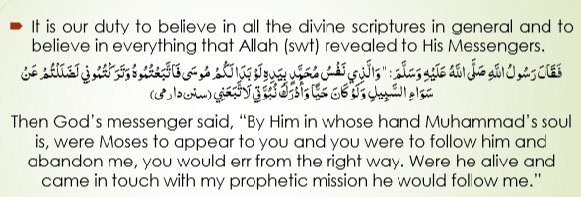
Explanation:
Belief in divine books means accepting that Allah revealed scriptures to His prophets for human guidance. While previous books were for specific nations and altered over time, the Qur’an is the final and preserved revelation for all people. Prophet Muhammad ﷺ said even earlier prophets like Musa would have followed him had they lived during his time.

3. Belief in Allah’s Messengers
Brief Notes:
- Prophets sent to guide mankind with truth.
- Must believe in all prophets equally.
- About 124,000 prophets, 313 messengers.
- Rasool: brings new book/law. Comes with a new shariah or new book
- Nabi: continues previous law. No new shariah or book, but they follow the shariah of previous or existing Rasool.
The meaning of faith in Allah’s messengers is that one should firmly believe that Allah SWT sent them to mankind to guide them to the way of truth. They were truthful and faithful, and they all delivered the message of Allah SWT in full.
Explanation:
Allah sent prophets to every nation, each truthful and trustworthy. Denying even one prophet equals denying them all (Qur’an 4:150–151). Risalat (messengership) is divinely chosen, not earned. Prophets explain life’s purpose (to worship Allah), convey revelation, demonstrate worship, and set moral standards. The Qur’an orders obedience to the Prophet ﷺ as obedience to Allah.

4. Special Status of Prophet Muhammad ﷺ
Brief Notes:
- Seal of prophets (final messenger).
- Universal messenger (for all humans & jinn).
- Role model for all times.
- Intercessor on Day of Judgment.
Explanation:
Prophet Muhammad ﷺ is the last prophet; no prophet will come after him. Qur’an (33:40) calls him the Seal of the Prophets. He was sent as a mercy for all worlds (7:158). His character is the best example (33:21). On Qiyamah, he will intercede for his followers. The belief in finality of prophethood is central to Islam.

5. Belief in the Hereafter (Akhirat)
Brief Notes:
- This world = place of deeds (Dar-ul-Amal).
- Hereafter = place of judgment (Dar-ul-Jaza).
- Stages: death, grave, resurrection, scale of deeds, bridge, paradise/hell.
- Akhirat ensures justice and accountability.
Explanation:
Belief in the Hereafter is crucial. Qur’an (67:2) says life and death are a test. The Hereafter balances justice since many escape punishment here. It motivates good deeds, patience, and worship. Life in dunya is temporary, while akhirat is eternal. Events include grave questioning, resurrection, scales (Mizan), crossing the bridge (Sirat), and final judgment.

6. Signs of Qayamat (Last Day)
Brief Notes:
- Only Allah knows the exact time.
- Minor signs: ignorance, adultery, interest, music, alcohol, disobedience of parents, earthquakes, women clothed yet naked, bad leaders.
- Major signs: Imam Mehdi, Dajjal, descent of Isa A.S, Yajooj Majooj.
Explanation:
Qur’an (33:63) says only Allah knows when Qiyamah will occur. However, Prophet ﷺ described signs. Minor signs include widespread corruption and immorality. Major signs will dramatically change the world and signal the approach of the Last Hour. These remind believers to prepare through faith and good deeds.

7. Belief in Predestination (Qadr)
Brief Notes:
- Allah knows everything (good or bad).
- His knowledge doesn’t cancel human free will.
- Two kinds of matters:
  - Optional: choices (studying, working, etc.).
  - Non-optional: death, illness, results.
Explanation:
Qadr means Allah’s timeless knowledge of all events. Qur’an (18:29) says whoever wills may believe or disbelieve. Humans have freedom in choices but outcomes are controlled by Allah. Believing in Qadr builds trust in Allah, patience in hardships, and gratitude in blessings. It also reminds us that everything happens by Allah’s wisdom.

✅ Now all five articles of faith (2–6) are covered with both notes and explanations.
👉 Do you want me to also make a super-short last-minute revision sheet (1–2 lines per topic) for this file?
Got it 👍 You want me to cover your file “Articles of Faith (2–6)” line by line, turning every single topic into brief notes + explanation in order. I’ll structure it exactly as your PDF presents.

📖 Articles of Faith (2–6) – Line by Line Notes & Explanation

Belief in Allah’s Angels
Note: Faith in angels is mandatory; denying them is disbelief.
Explanation: Angels are Allah’s creation from light (Hadith: Sahih Muslim). They have no physical needs, desires, or disobedience. Qur’an (16:50) confirms they fear Allah and obey His commands.
Well-known angels:
- Jibreel: Brings revelation.
- Mikaeel: Manages rain/sustenance.
- Israfeel: Will blow the trumpet.
- Izraeel: Angel of death.
- Kiraman Katibeen: Record deeds.
- Munkir & Nakeer: Question in the grave.

Belief in Allah’s Books
Note: Belief in all divine scriptures is obligatory.
Explanation: Every book revealed by Allah must be believed in. Hadith (Sunan Darimi) states if Prophet Musa were alive, he would follow Muhammad ﷺ.
Four major revealed books:
- Torah → Musa (A.S)
- Zaboor → Dawood (A.S)
- Injeel → Isa (A.S)
- Qur’an → Muhammad ﷺ (final, preserved, universal)

Belief in Allah’s Messengers
Note: Must believe Allah sent prophets to guide mankind.
Explanation: Prophets were truthful, trustworthy, and delivered Allah’s full message. Denying one prophet equals denying them all (Qur’an 4:150–151).
Rasool vs Nabi:
- Rasool: Brings new Shariah/book.
- Nabi: Continues previous Shariah.
- Total: 124,000 Prophets, 313 Messengers (exact only known to Allah).
Need for Prophethood:
- Explains purpose of life (“I created jinn & men only to worship Me” – Qur’an 51:56).
- Delivers divine guidance. Prophets deliver reliable and error-free guidance directly from Allah (swt)
- Demonstrates worship.:Through prayer, fasting, charity, etc.
- Teaches moral standards. •They teach what is right and wrong beyond cultural norms.

Position of Prophethood:
- Obedience to Prophet ﷺ = obedience to Allah (Qur’an 4:80).
- Qur’an commands: “Whatever the Prophet gives you, take; whatever he forbids, avoid.” (59:7).
- Prophet ﷺ explains Allah’s revelation (Qur’an 16:44).
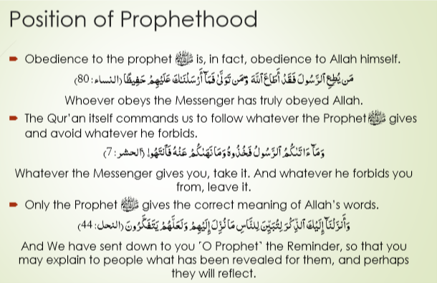
Special characteristics of Prophet Muhammad ﷺ:
- Seal of Prophets (final).; there will be no prophet after Muhammad
- Universal messenger (for all mankind/jinn).

- Best role model
“Indeed, in the messenger of Allah you have a good example to follow. (Qur’an 33:21).
- Intercessor on Day of Judgment.: Granted Shafa‘at-e-Kubra.

Finality of Prophethood
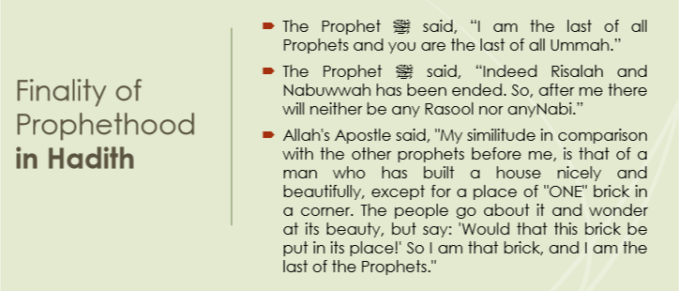

Note: Muhammad ﷺ is the last Prophet; none will come after him.
Explanation: Qur’an (33:40): “He is the Messenger of Allah and the Seal of the Prophets.” More than 100 Qur’anic verses and 200 ahadith affirm this.
Proofs:
- Qur’an (7:158) – Prophet ﷺ sent for all mankind.
- Qur’an (5:3) – Religion perfected through him.
- Hadith – “There will be no Prophet after me.”
- Hadith – Prophet ﷺ likened himself to the last missing brick in a wall of Prophets.
- Battle of Yamamah (against false claimant Musailamah).
The Battle of Yamamah
- Fought against Musalimah Kazzab (False claimant of prophethood)
- 1200 Muslims were martyred
- Many of them were Hafiz-e-Quran

Belief in the Hereafter (Akhirat)

A Muslim should firmly believe in all the events of hereafter (questioning, resurrections, reckoning, etc.) which are mentioned by Allah (swt) and his Messenger
Note: Firm belief in all stages of life after death.
Explanation: Qur’an (67:2) – Life & death are a test. This world is Dar-ul-Amal (place of deeds), while the Hereafter is Dar-ul-Jaza (place of reward/punishment).
Importance:
- Ensures ultimate justice.
- Makes people morally responsible.
- Encourages good deeds.
- Protects from greed & materialism.
- Brings hope during trials.
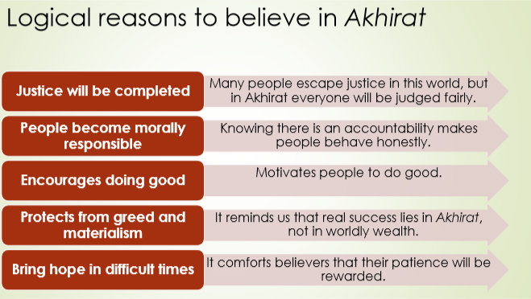
Comparison – Dunya vs Akhirat:
- Dunya = temporary, trials, unequal justice, sickness, uncertain.
- Akhirat = eternal, perfect justice, peace, eternal youth, certainty.
Dunya | Akhirat
Temporary & Short-lived | Perfect peace, no sorrow
Limited and mixed with trials | Perfect peace, no sorrow
Wealth & success is temporary, often unequal | Everlasting and based on deeds
Justice sometimes delayed or denied | Perfect and complete Justice by Allah (swt)
Uncertain, we don’t know when it ends | Absolutely certain
Health & Body – Weak, aging, full of sickness | Eternal youth, strength and no illness

Stages of Hereafter:
- Death: Everyone must die (Qur’an 3:185). Deeds end except ongoing charity, beneficial knowledge, or pious children’s prayers.
- Grave: “Grave is either a garden of paradise or a pit of hellfire.” Questions: Who is your Lord? Who is your Prophet? What is your religion?
- Resurrection: Sur will be blown; all will rise again (Qur’an 39:68). Denial refuted (Qur’an 64:7). Example: People of the Cave (Ashab-e-Kahf).
- The Scale (Mizan): Deeds weighed with perfect justice (Qur’an 21:47).
- The Bridge (Sirat): Path over hell to paradise.
Impacts of Akhirat:
- Gives purpose to life.
- Strengthens accountability.
- Motivates good deeds and worship.
- Develops patience in trials.
Signs of Qayamat:
- Minor Signs: ignorance, adultery, interest, music, alcohol, tall buildings, killings, disobedience to parents, earthquakes, immodesty, bad rulers.
- Major Signs: Imam Mehdi, Dajjal, descent of Isa (A.S), Yajooj & Majooj.

Belief in Predestination (Qadr)
Note: Allah knows everything – good or bad.
Explanation: Allah’s knowledge is timeless. It does not cancel human free will. Qur’an (18:29) – Whoever wills may believe or deny.
Types of matters:
- Optional: choices (studying, working, taking medicine).
- Non-optional: death, illness, results beyond control.
Key point: Humans act with free will, but Allah already knows outcomes. This builds patience in hardship and gratitude in blessings.

